AWX-Management Setup

Contents

1. Git Project Creation 2

1.1 Setup AWX-Management Project 2

1.2 Setup Ruckus-ICX-AWX-Ansible Project 4

2. Setup Credentials for AWX-Management 5

2.1 Create a Custom Credential Type 5

2.2 Add AWX Login Credentials 7

3. Setup Localhost Inventory 8

3.1 Create AWX Server Inventory 8

3.2 Add AWX Server Host 9

4. Setup AWX-Management Templates 10

4.1 AWX-MGMT-Create-Templates 10

4.2 AWX-MGMT-Remove-Templates 13

4.3 AWX-MGMT-Update-Templates 16

5. Generating New Templates 19

5.1 Create templates for Ruckus-ICX-AWX-Ansible 19

5.2 View Templates 21

6. Updating Playbooks and Templates 23

6.1 Manual update of project playbooks 23

6.2 Manual update of project templates 24

6.3 Automated update of project playbooks 26

6.4 Automated update of project templates 28

# 1. Git Project Creation

## 1.1 Setup AWX-Management Project

To add the AWX-Management playbooks to a project, first click on the **Projects** menu on the left, then click the **+** button:

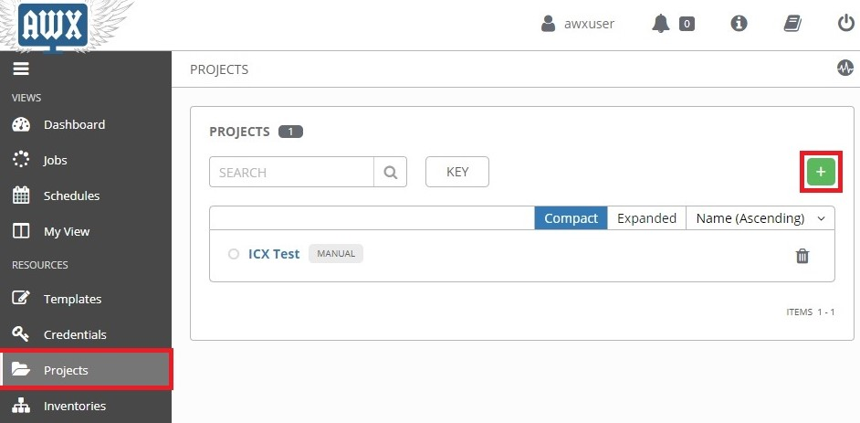

This opens the **New Project** page:

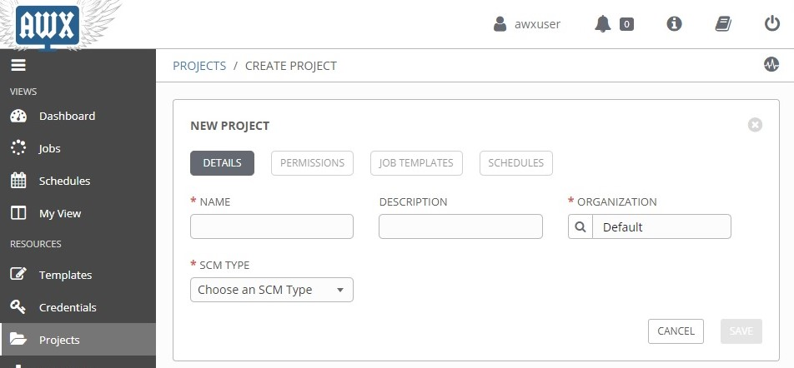

Enter the following into the required fields:

**NAME:** Name the project "*AWX-Management*"

**SCM TYPE:** Select "*Git*"

**SCM URL:** Type in "*https://github.com/steppb/AWX-Management*".

**Organization:** A project must have at least one organization. Here, "*Default*" is selected.

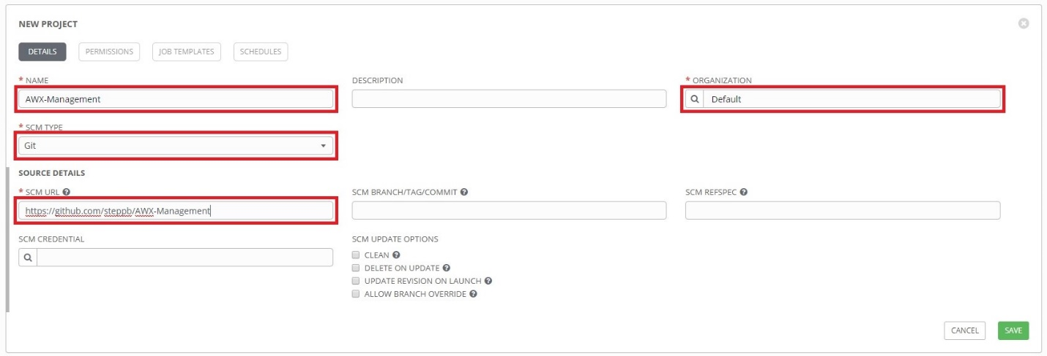

When you are finished, click **Save**.

At this point **AWX-Management** will be added to the list of projects and it will begin syncing with the Github repo. An animated green circle next to the project indicates the project is currently syncing. A static green circle indicates the project has successfully finished syncing and the playbooks are ready for use:

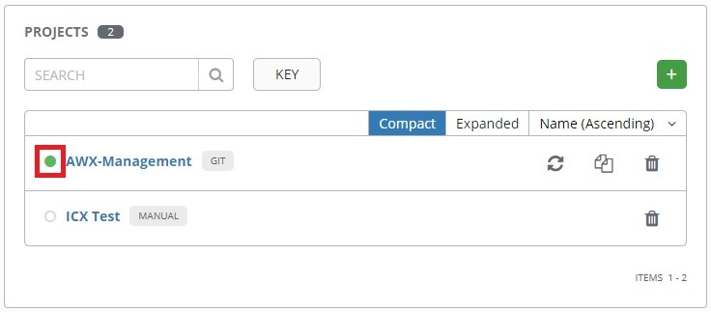

A red circle would indicate a failure during syncing. You can click on the circle to bring up a status window showing the details of the syncing process.

## 1.2 Setup Ruckus-ICX-AWX-Ansible Project

To add the "Ruckus-ICX-AWX-Ansible" playbooks to a project, first click the **Templates** menu on the left, then click the **+** button:

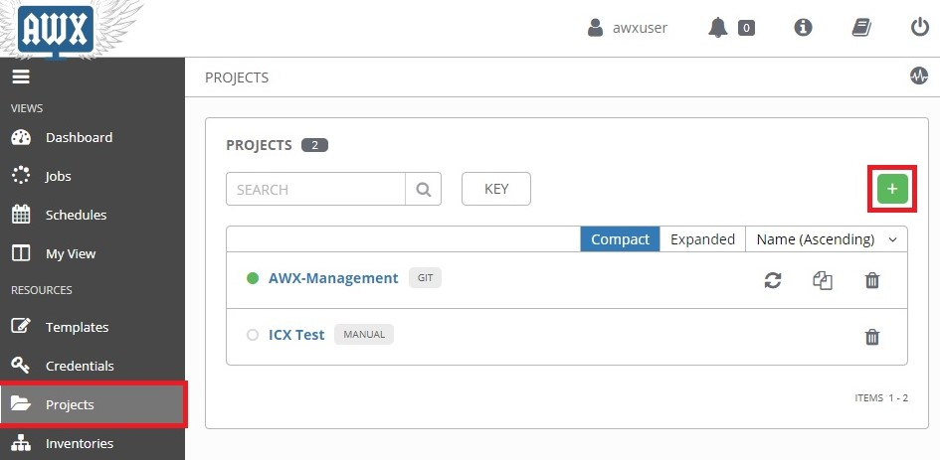

This opens the **New Project** page. Enter the following into the required fields:

**Name:** Enter the name of the project. Here, it is named "*Ruckus-ICX-AWX-Ansible"*.

**SCM Type:**  Select "*Git*".

**SCM URL:** Enter "*https://github.com/steppb/Ruckus-ICX-AWX-Ansible".*

**Organization:** A project must have at least one organization. Here, "*Default*" is selected.

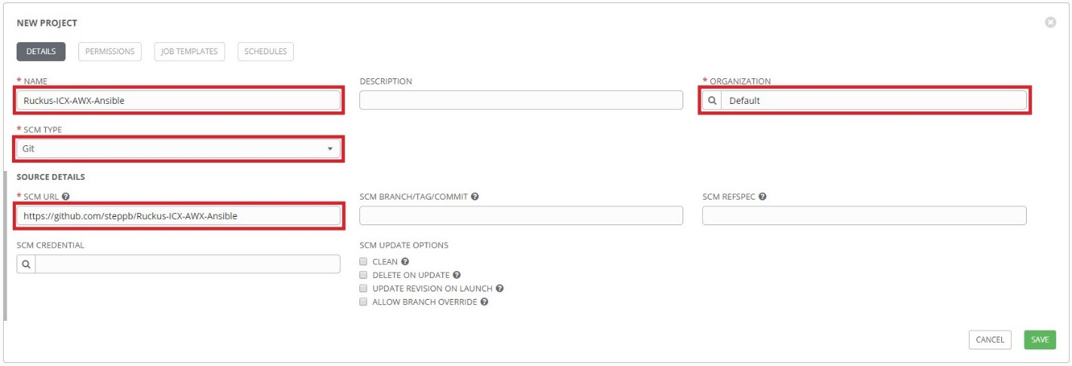

When you are finished, click **Save**.

# 2. Setup Credentials for AWX-Management

The "AWX-Management" playbooks contain variables that need to be defined with credentials for logging into the AWX REST API framework. In order to accomplish this, a custom credential type will need to be created.

## 2.1 Create a Custom Credential Type

First, click the **Credential Types** menu on the left, then click the **+** button:

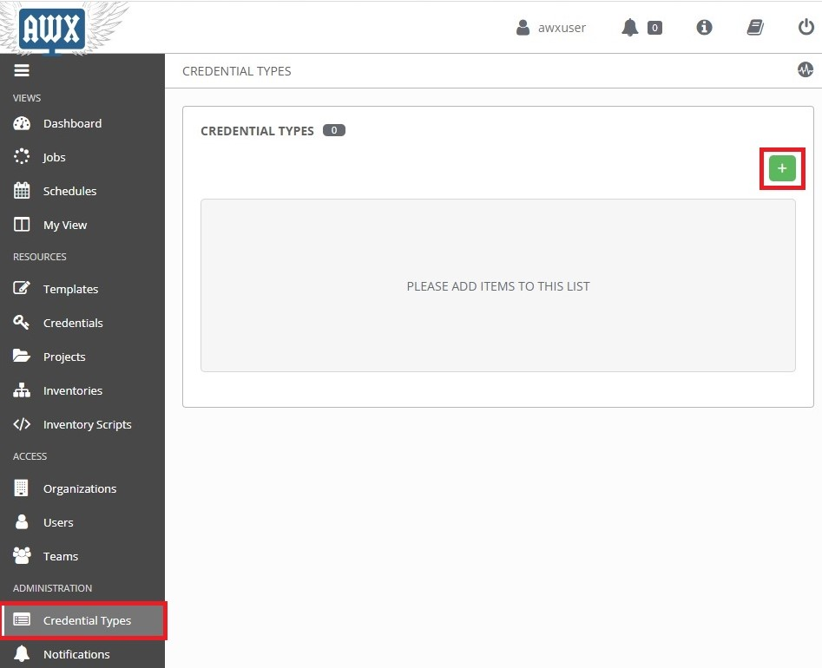

This opens the **New Credential Type** page.

Enter the following into the required fields:

**NAME:** Enter the name of the credential type. Here, it is named "*AWX REST API*"

**DESCRIPTION:** (Optional) Enter a description.

**INPUT CONFIGURATION:** Ensure **YAML** is selected. Then copy and paste the following into the box:

|  |
| --- |
| fields:  - id: username  type: string  label: AWX Username  - id: password  type: string  label: AWX Password  secret: true  required:  - username  - password |

**INJECTOR CONFIGURATION:** Ensure **YAML** is selected. Then copy and paste the following into the box.

|  |
| --- |
| extra_vars:  awxlogin_user: '{{username}}'  awxlogin_pass: '{{password}}' |

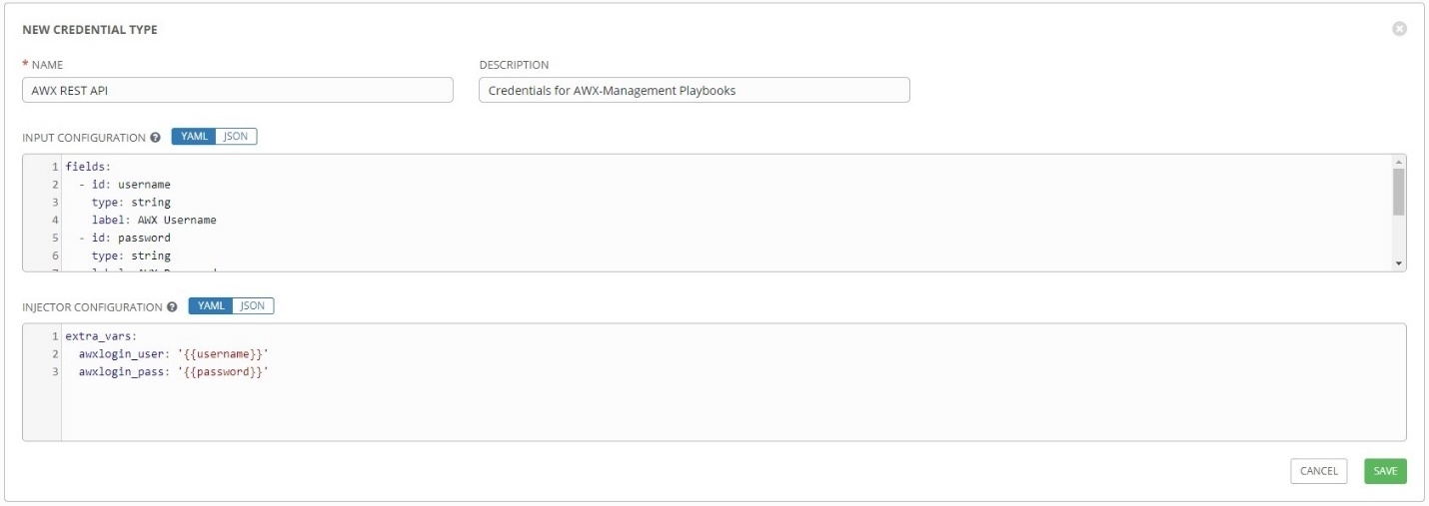

When you are finished, click **Save**.

Now that the custom credential type has been set up, a credential set for the AWX-Management playbooks can be created.

## 2.2 Add AWX Login Credentials

Click on the **Credentials** menu on the left, then click the **+** button:

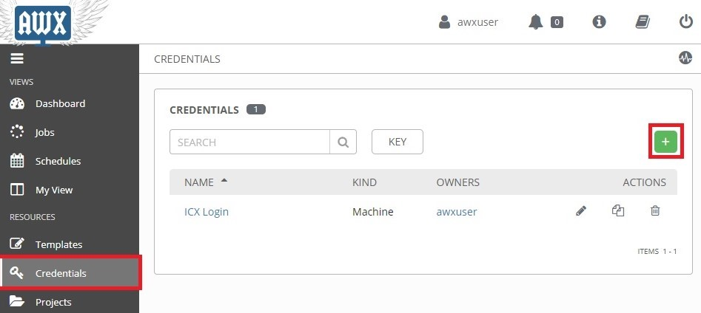

This opens the **New Credential** page.

Enter the following into the required fields:

**NAME:** Name of the credential set. Here it is named "*AWX Login*"

**CREDENTIAL TYPE:** Select the custom credential type. Here it is named "*AWX REST API*"

**AWX USERNAME** & **AWX PASSWORD:** Type in the credentials used to login to AWX.

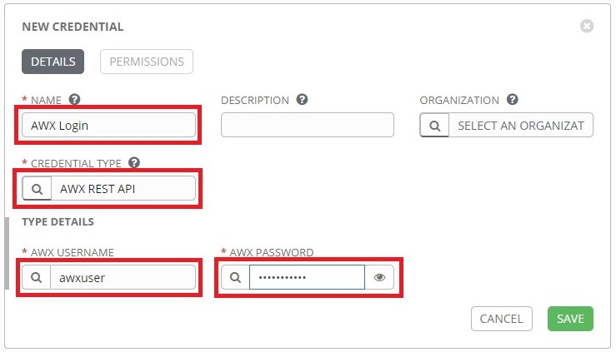

When you are finished, click **SAVE**.

# 3. Setup Localhost Inventory

## 3.1 Create AWX Server Inventory

An inventory for the AWX Server itself will need to be setup in order to execute the AWX-Management templates against itself.

Click the **Inventories** button from the left navigation bar. Click the **+** button, then click **Inventory** from the drop-down menu:

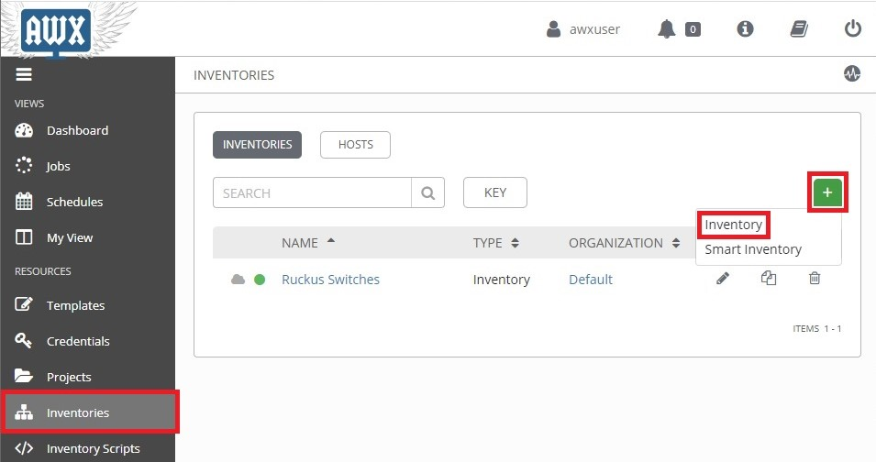

This opens the **New Inventory** page.

Complete the following fields:

**NAME:** Enter a name for the Inventory. Here the inventory is named "*AWX Server*".

**Organization:** Select the organization the inventory belongs to. Here "*Default*" is selected.

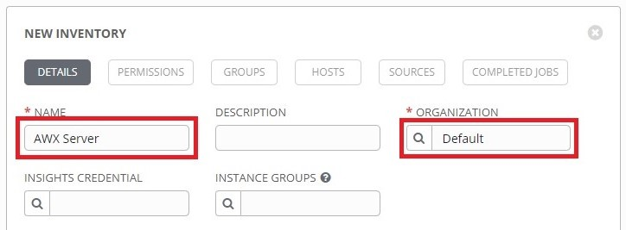

When you are finished, click the **Save** button.

## 3.2 Add AWX Server Host

Click the **Hosts** tab, then click the **+** button:

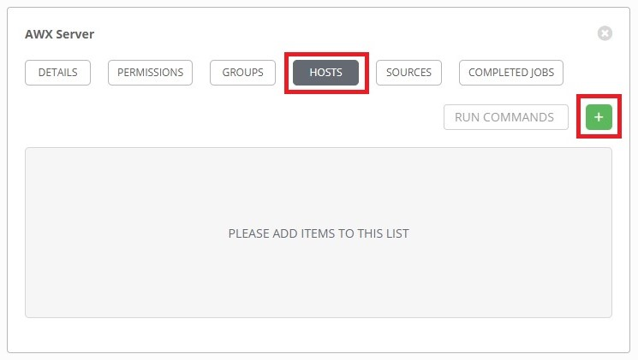

This opens the **Create Host** page.

Complete the following fields:

**HOST NAME:** Enter the hostname of the AWX server. Here it is called "*awxserver*".

**VARIABLES:** Type in "*ansible_host:* " followed by the IP address of the AWX server.

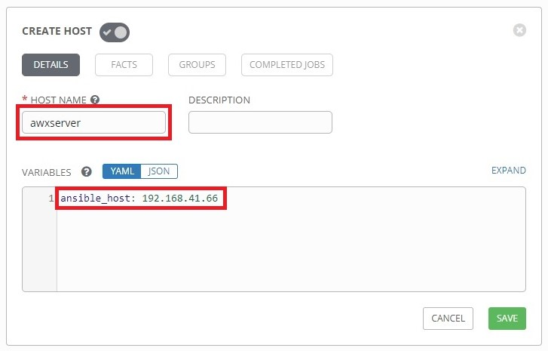

Click **Save** when done, and the AWX server will be added to the Inventory's list of hosts.

# 4. Setup AWX-Management Templates

## 4.1 AWX-MGMT-Create-Templates

Click the **Templates** button from the left navigation bar. Click the **+** button, then click **Job Template** from the drop-down menu:

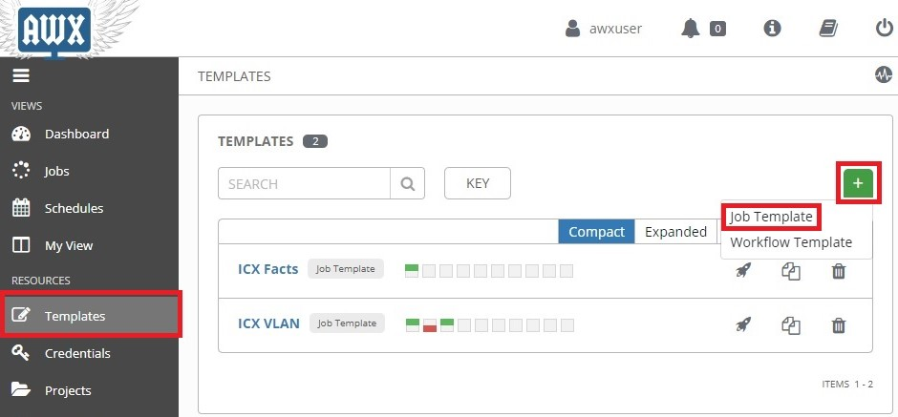

This opens the **New Job Template** page.

Complete the following fields:

**NAME:** Enter a name for the template. Here it is named "*AWX-MGMT-Create-Templates*"

**DESCRIPTION:** Enter a description of the template. (Optional)

**JOB TYPE:** Select **Run**.

**INVENTORY:** Select the inventory that contains the AWX server. Here it is "*AWX Server*"

**PROJECT:** Select **AWX-Management**.

**PLAYBOOK:** Select **AWX-MGMT-Create-Templates.yml**.

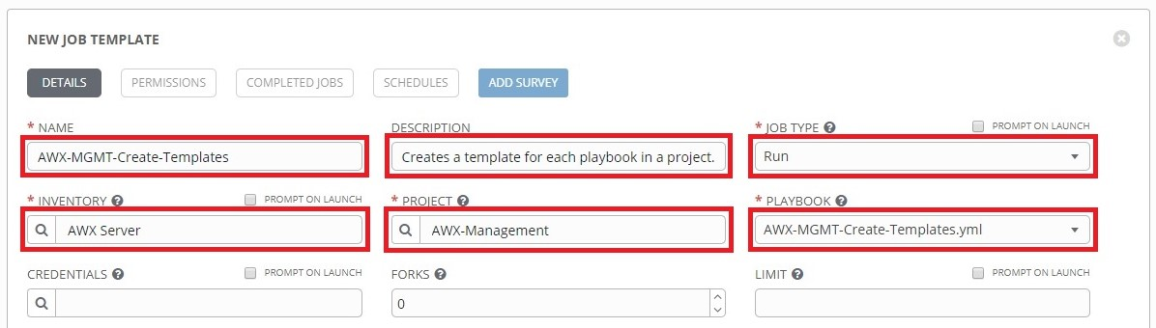

**CREDENTIALS:** Click the  button to open a separate window. Select the custom credential type in the **CREDENTIAL_TYPE** drop-down menu, then select the AWX Login credentials:

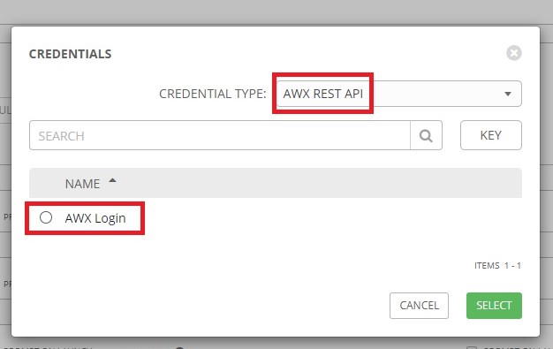

Click **Select** when done, and the window will close.

Scroll to the bottom of the **New Job Template** page. For **EXTRA VARIABLES**, define *template_project_inventory* with the name of the inventory that contains the switches:

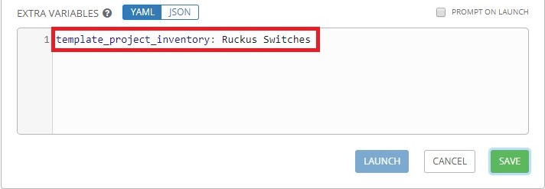

Click **Save** to save the template.

To setup a survey for this template, click the **Add Survey** button:

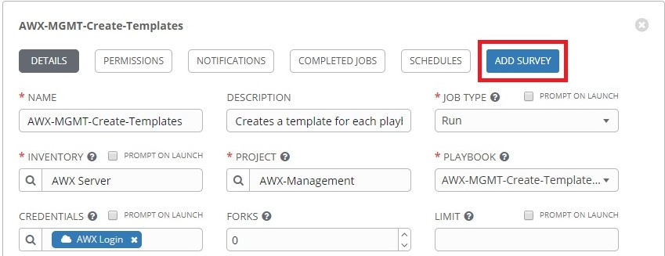

This will open the **Add Survey Prompt** window.

Complete the following fields:

**PROMPT:** Type in a title for the prompt.

**DESCRIPTION:** Type in a question that will be asked when the template is launched.

**ANSWER_VARIABLE_NAME:** Type "*template_project_name*" without the quotes. This is the variable that will be defined by the answer.

**ANSWER_TYPE:** Select **Multiple Choice (single select)**.

**MULTIPLE_CHOICE_OPTIONS:** Type in the name of the "*Ruckus-ICX-AWX-Ansible*" project along with the names of any other projects you would like this this template to run against.

**REQUIRED:** Ensure this is checked.

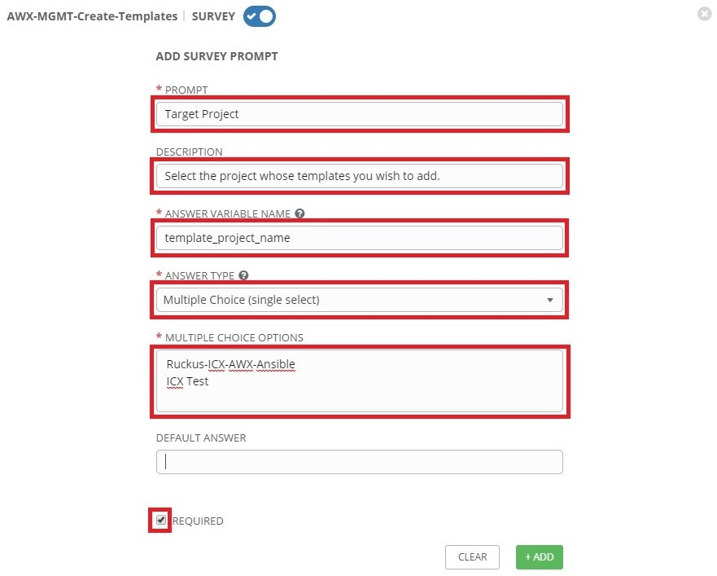

Click **+Add** when done. Then click **Save**.

## 4.2 AWX-MGMT-Remove-Templates

Click the **Templates** button from the left navigation bar. Click the **+** button, then click **Job Template** from the drop-down menu:

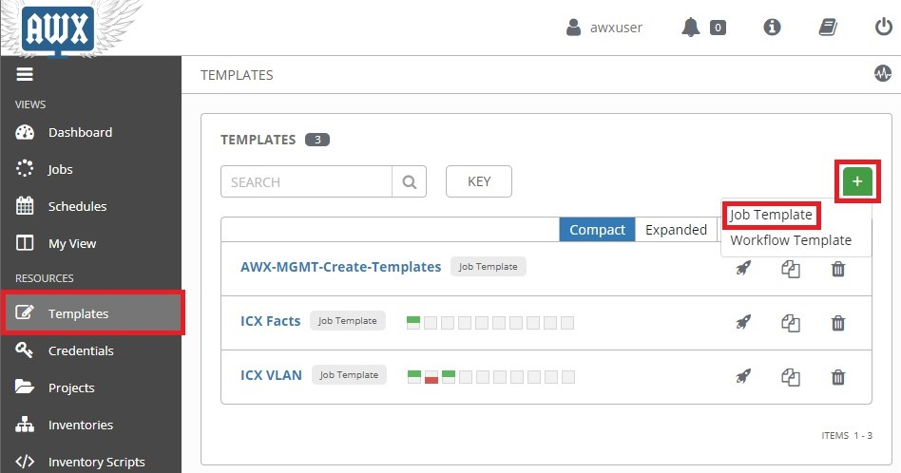

This opens the **New Job Template** page.

Complete the following fields:

**NAME:** Enter a name for the template. Here it is named "*AWX-MGMT-Remove-Templates*"

**DESCRIPTION:** Enter a description of the template. (Optional)

**JOB TYPE:** Select **Run**.

**INVENTORY:** Select the inventory that contains the AWX server. Here it is "*AWX Server*"

**PROJECT:** Select **AWX-Management**.

**PLAYBOOK:** Select **AWX-MGMT-Remove-Templates.yml**.

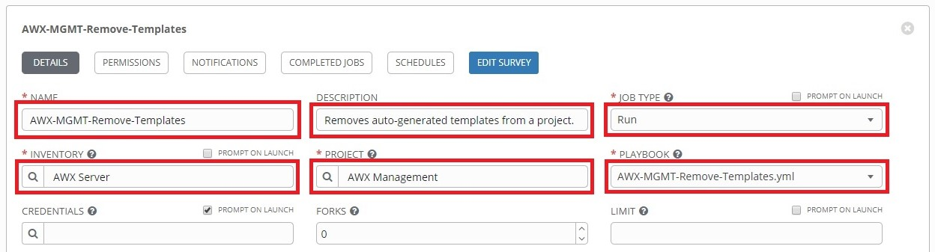

**CREDENTIALS:** Click the  button to open a separate window. Select the custom credential type in the **CREDENTIAL_TYPE** drop-down menu, then select the AWX Login credentials:



Click **Select** when done, and the window will close.

Click **Save** to save the template.

Next click the **Add Survey** button:

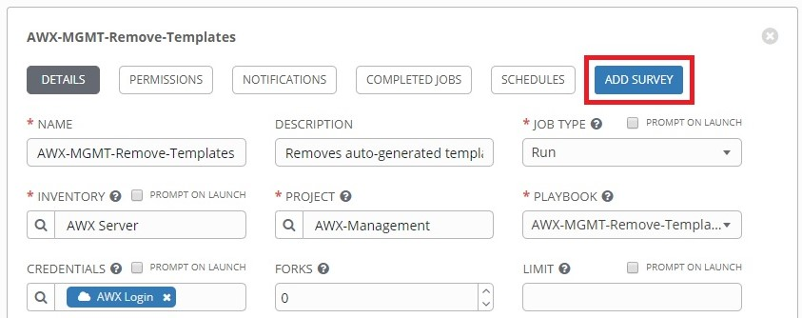

This will open the **Add Survey Prompt** window.

Complete the following fields:

**PROMPT:** Type in a title for the prompt.

**DESCRIPTION:** Type in a question that will be asked when the template is launched.

**ANSWER_VARIABLE_NAME:** Type "*template_project_name*" without the quotes. This is the variable that will be defined by the answer.

**ANSWER_TYPE:** Select **Multiple Choice (single select)**.

**MULTIPLE_CHOICE_OPTIONS:** Type in the name of the "*Ruckus-ICX-AWX-Ansible*" project along with the names of any other projects you would like this this template to run against.

**REQUIRED:** Ensure this is checked.

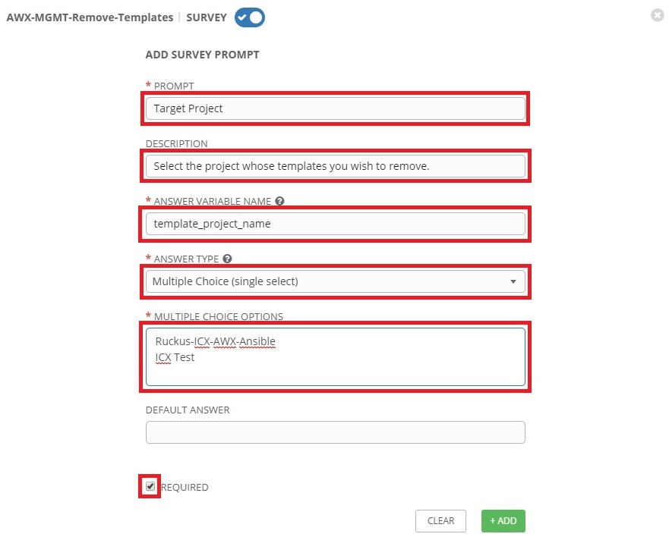

Click **+Add** when done. Then click **Save**.

## 4.3 AWX-MGMT-Update-Templates

Click the **Templates** button from the left navigation bar. Click the **+** button, then click **Job Template** from the drop-down menu:

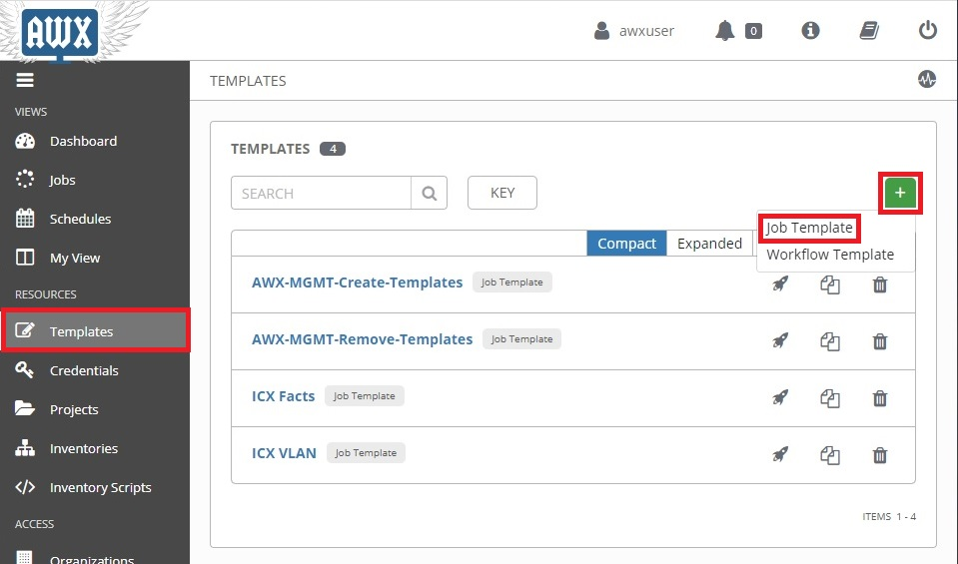

This opens the **New Job Template** page.

Complete the following fields:

**NAME:** Enter a name for the template. Here it is named "*AWX-MGMT-Update-Templates*".

**DESCRIPTION:** Enter a description of the template. (Optional)

**JOB TYPE:** Select **Run**.

**INVENTORY:** Select the inventory that contains the AWX server. Here it is "*AWX Server*".

**PROJECT:** Select **AWX-Management**.

**PLAYBOOK:** Select **AWX-MGMT-Update-Templates.yml**.

**CREDENTIALS:** Select "*AWX Login*".

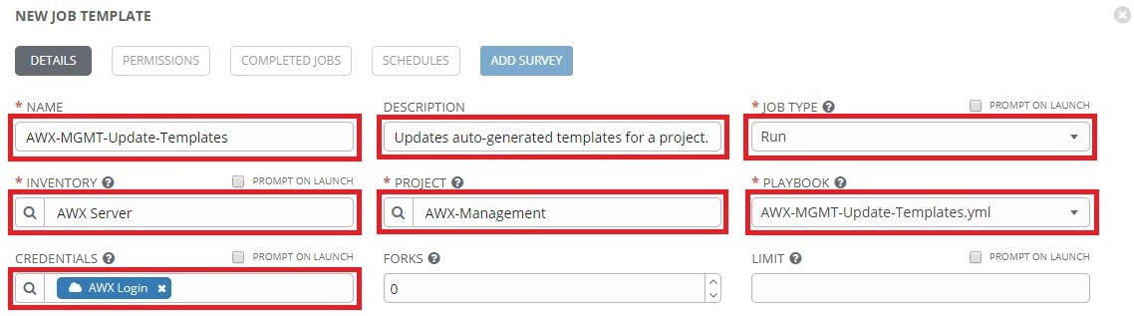

Click **Save** when finished.

Next click the **Add Survey** button:

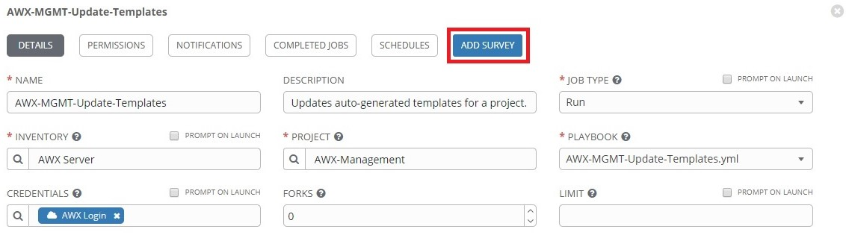

This will open the **Add Survey Prompt** window.

Complete the following fields:

**PROMPT:** Type in a title for the prompt.

**DESCRIPTION:** Type in a question that will be asked when the template is launched.

**ANSWER_VARIABLE_NAME:** Type "*template_project_name*" without the quotes. This is the variable that will be defined by the answer.

**ANSWER_TYPE:** Select **Multiple Choice (single select)**.

**MULTIPLE_CHOICE_OPTIONS:** Type in the name of the "*Ruckus-ICX-AWX-Ansible*" project along with the names of any other projects you would like this this template to run against.

**REQUIRED:** Ensure this is checked.

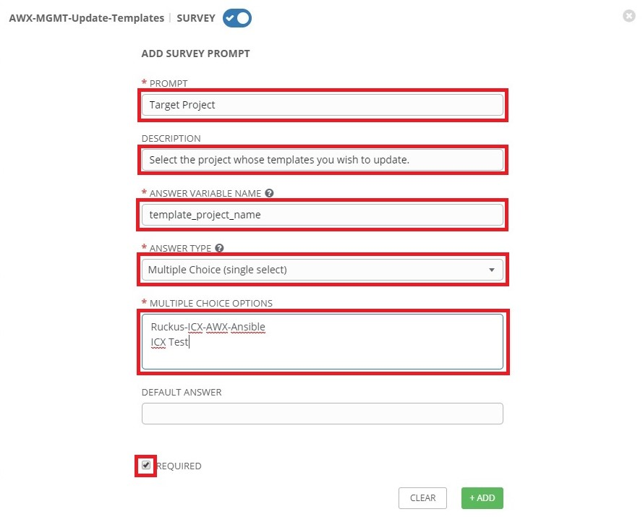

Click **+Add** when done.

Set up the 2nd prompt by completing the following fields:

**PROMPT:** Type in a title for the prompt.

**DESCRIPTION:** Type in a question that will be asked when the template is launched.

**ANSWER_VARIABLE_NAME:** Type "*template_update_section*" without quotes.

**ANSWER_TYPE:** Select **Multiple Choice (multiple select)**.

**MULTIPLE_CHOICE_OPTIONS:** Type in "*Prompts*", "*Descriptions*", and "*Comments*" as it entered below.

**DEFAULT ANSWER:** Type in "*Prompts*", "*Descriptions*", and "*Comments*" as it entered below.

**REQUIRED:** Ensure this is checked.

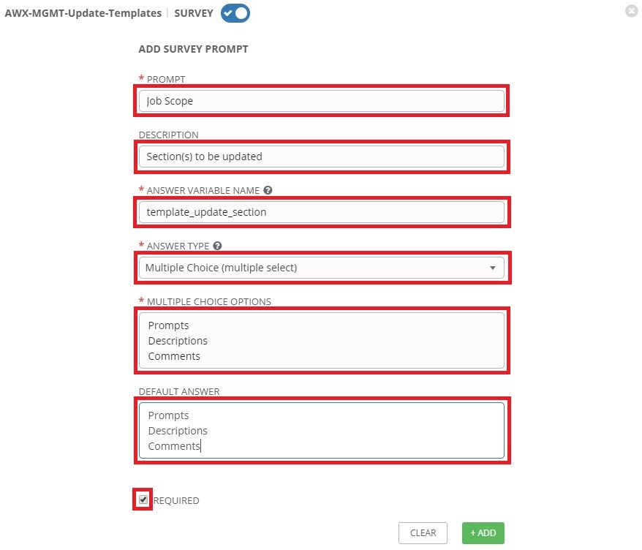

When finished, click the **+Add** button, then click **Save**.

# 5. Generating New Templates

## 5.1 Create templates for Ruckus-ICX-AWX-Ansible

Click the **Templates** button from the left navigation bar. Then click the launch () button next to **AWX-MGMT-Create-Templates**:

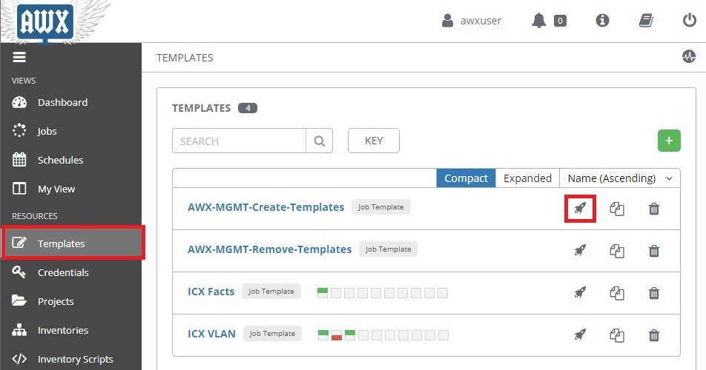

This will open the survey prompt that was created for the template. Open the drop-down menu and click on **Ruckus-ICX-AWX-Ansible**:

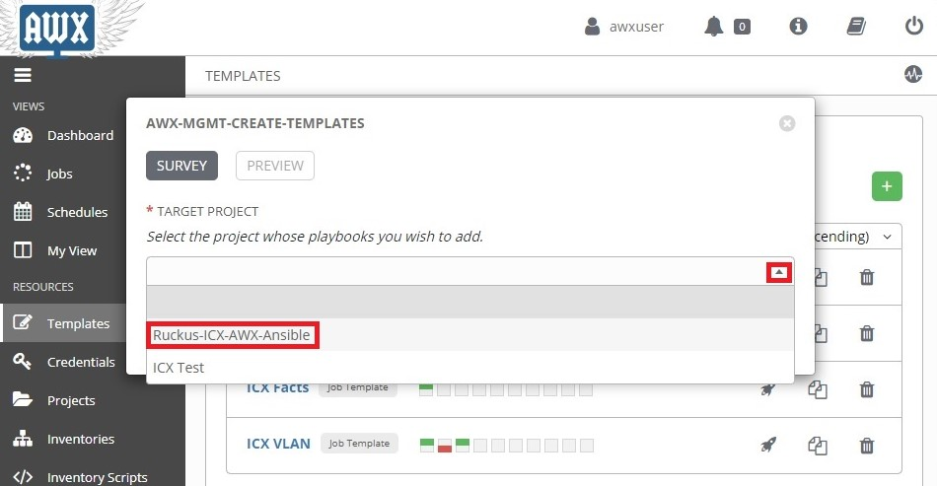

Click **Next** to display the preview screen which will display the variable definitions:

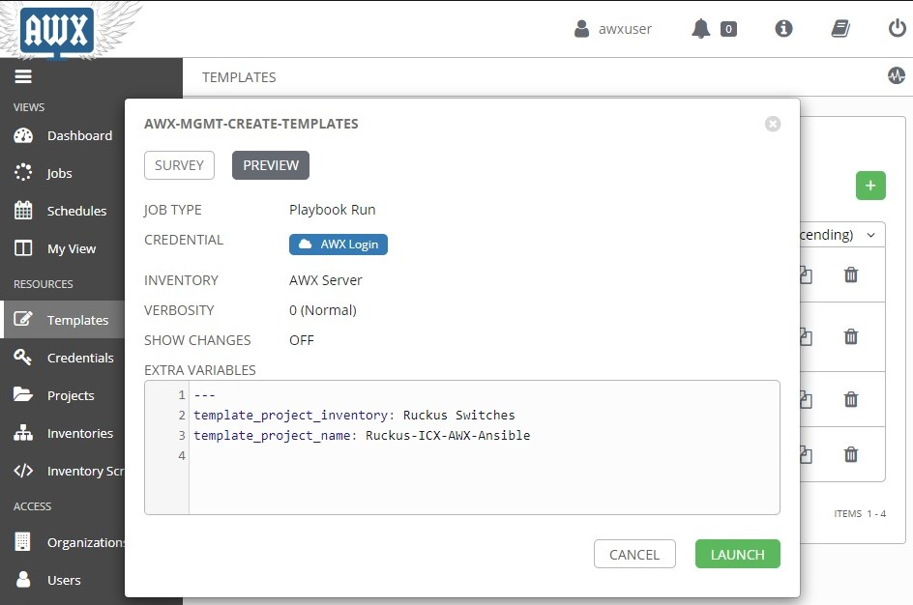

Click **Launch** to run the template. The **Details** page will display the job execution process. When the job has finished execution, the status should show **Successful.**

## 5.2 View Templates

Click the **Projects** button from the left navigation bar, then click **Ruckus-ICX-AWX-Ansible** to view the new templates:

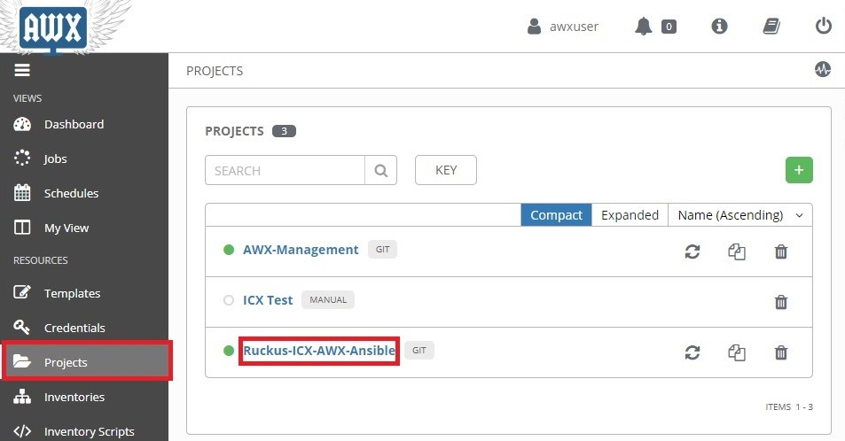

Click the **Job Templates** tab:

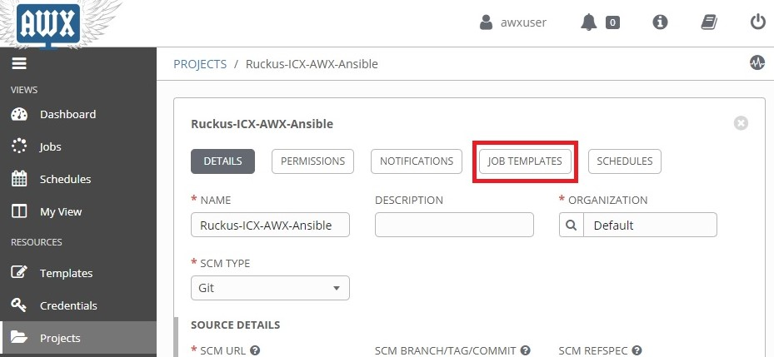

The new templates should now be visible in this tab:

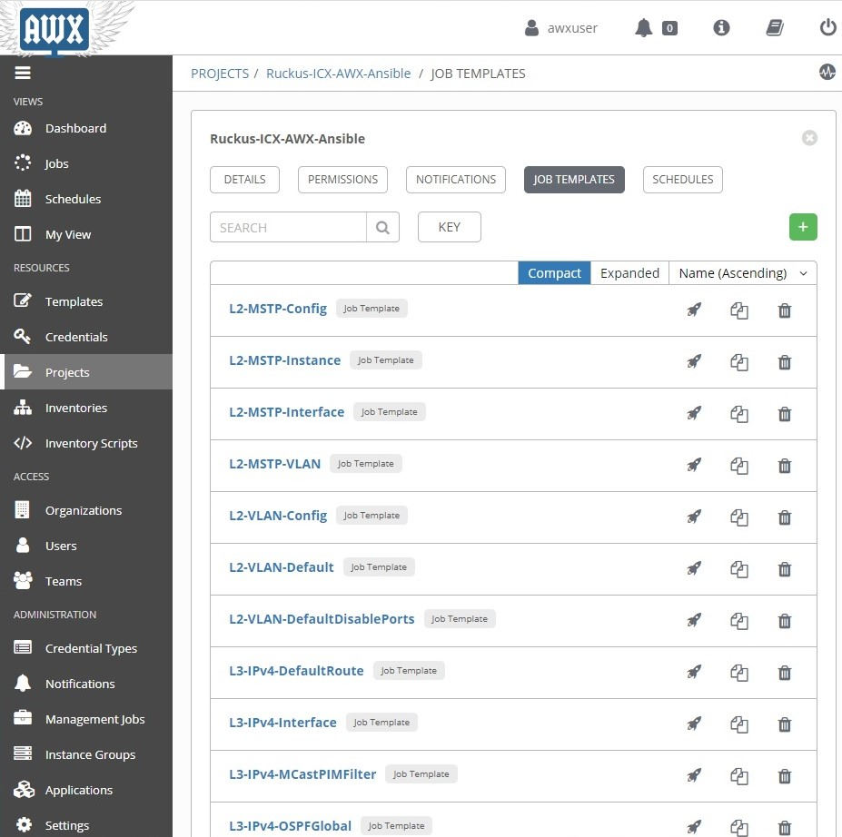

Note: While "*AWX-MGMT-Create-Templates*" is able to save playbook comments in the **Extra Variables** field of a Job Template, it is not possible to save comments using the AWX GUI. When the template is saved in the AWX GUI, the comments will disappear from the **Extra Variables** field. "*AWX-MGMT-Update-Templates*" can be run to re-add the playbook comments into the **Extra Variables** field.

# 6. Updating Playbooks and Templates

Git projects by default do not update local playbooks when changes occur upstream. The following section covers manual and automated methods of updating the templates and playbooks in a project.

## 6.1 Manual update of project playbooks

Click the **Projects** button from the left navigation window, then click the refresh () button for the "*AWX-Management*" and "*Ruckus-ICX-AWX-Ansible*" projects to sync playbooks with the upstream repository:

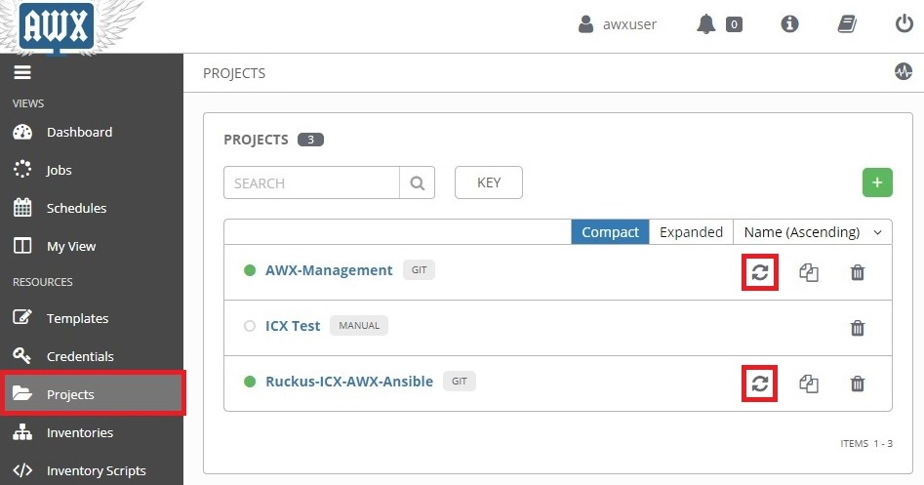

The "*AWX-MGMT-Create-Templates*" template will only create templates for playbooks that do not have a template assigned. The "*AWX-MGMT-Update-Templates*" template will only update preexisting templates. In order to ensure each playbook has an up-to-date template, both templates will need to be run. The "*AWX-MGMT-Create-Templates*" template can be run using the instructions in the "*Generating New Templates*" section above.

## 6.2 Manual update of project templates

Click the **Templates** button from the left navigation bar. Then click the launch () button next to **AWX-MGMT-Update-Templates**:

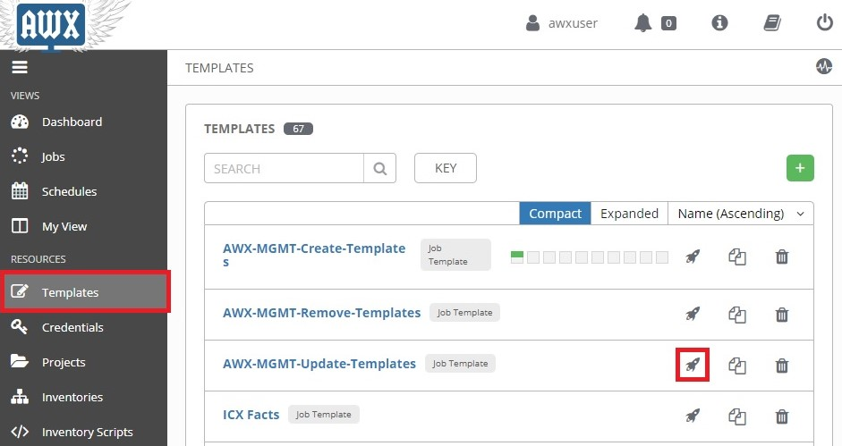

This will open the survey prompt that was created for the template. Open the drop-down menu and click on **Ruckus-ICX-AWX-Ansible** for the "*Target Project*" prompt:

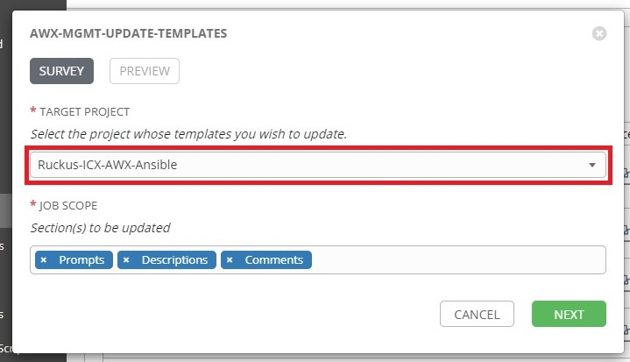

The **"***Job Scope*"prompt shows the three sections that will be updated by default. Updates for a section can be optionally skipped by clicking the **x**.

Click **Next** to display the preview screen which will display the variable definitions:

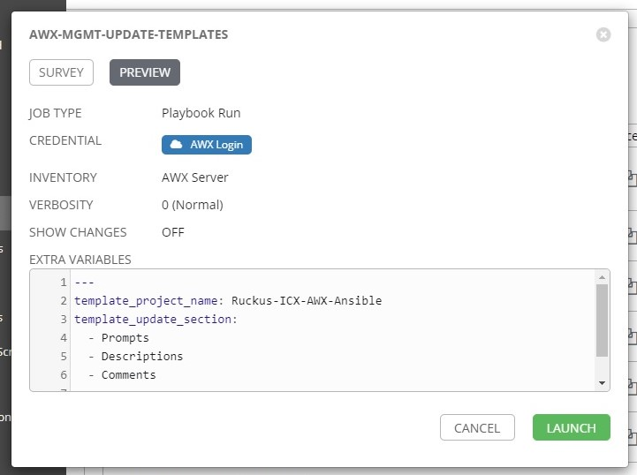

Click **Launch** to run the template. The **Details** page will display the job execution process. When the job has finished execution, the status should show **Successful.**

## 6.3 Automated update of project playbooks

The following will run through a schedule-based method to update both the playbooks and templates.

Click the **Projects** button from the left navigation menu. Then click the "*Ruckus-ICX-AWX-Ansible*" project:

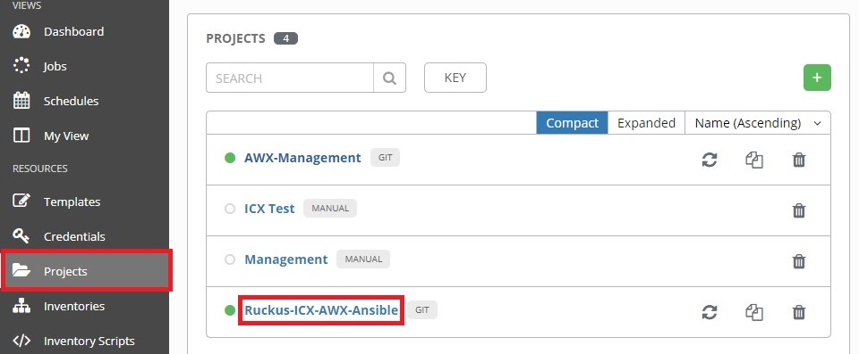

Click the **Schedules** tab, then click the **+** button:

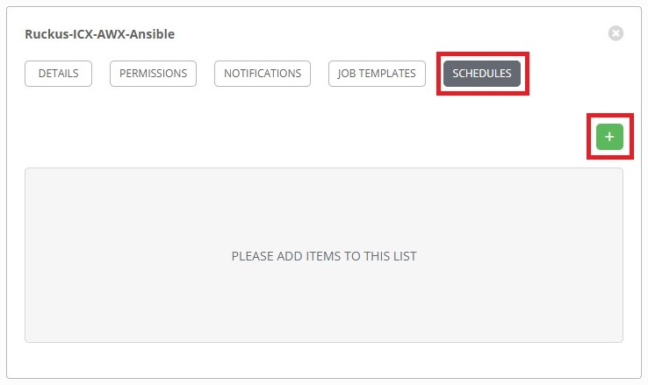

This will open the **Create Schedule** page. Complete the following fields:

**NAME:** Name of the schedule.

**START DATE:** First day the schedule takes effect.

**START TIME:** Time of first run (24-Hour Clock format).

**LOCAL TIME ZONE:** Time zone local to AWX Server.

**REPEAT FREQUENCY:** How often the sync will occur.

The following is an example of a sync that will occur daily at 11:30PM ET starting 4/29/2020:

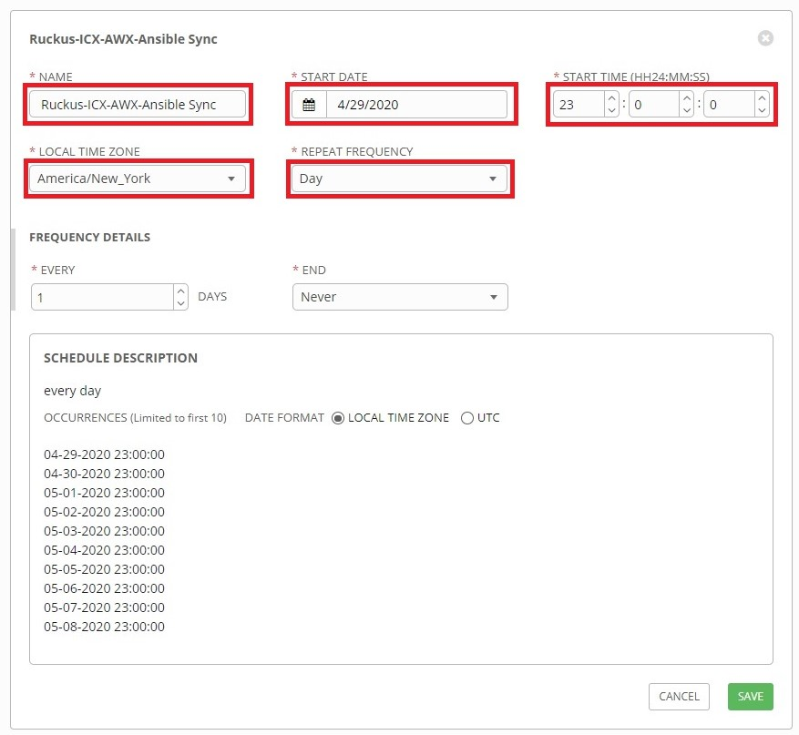

When finished, click **Save**.

If desired, automating the update of "*AWX-Management*" playbooks can be set up using the instruction above.

## 6.4 Automated update of project templates

Click the **Templates** button from the left navigation bar, then click "*AWX-MGMT-Create-Templates*":

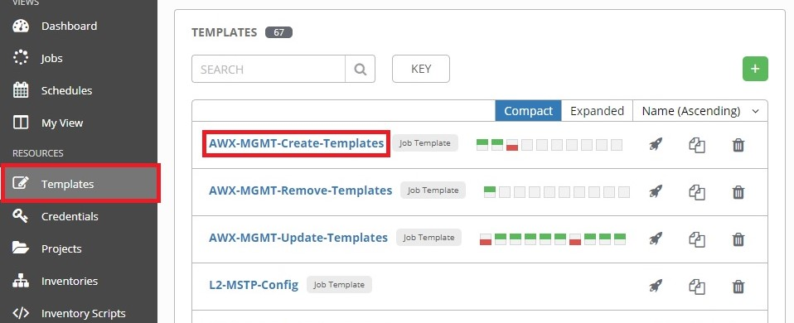

Click the **Schedules** tab, then click the **+** button:

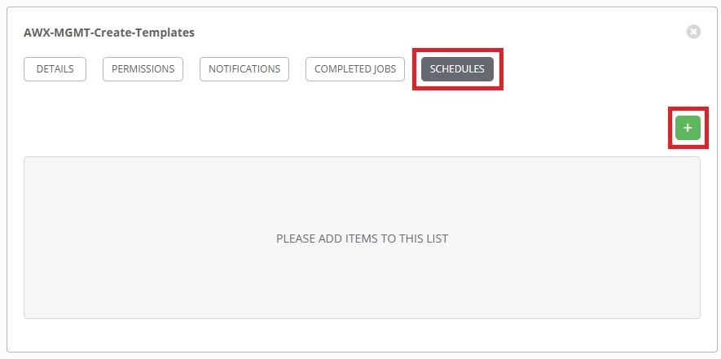

This will open the **Create Schedule** page. Complete the following fields:

**NAME:** Name of the schedule.

**START DATE:** First day the schedule takes effect.

**START TIME:** Time of first run (24-Hour Clock format).

**LOCAL TIME ZONE:** Time zone local to AWX Server.

**REPEAT FREQUENCY:** How often the sync will occur.

The following is an example of a sync that will occur daily at 11:35PM ET starting 4/29/2020:

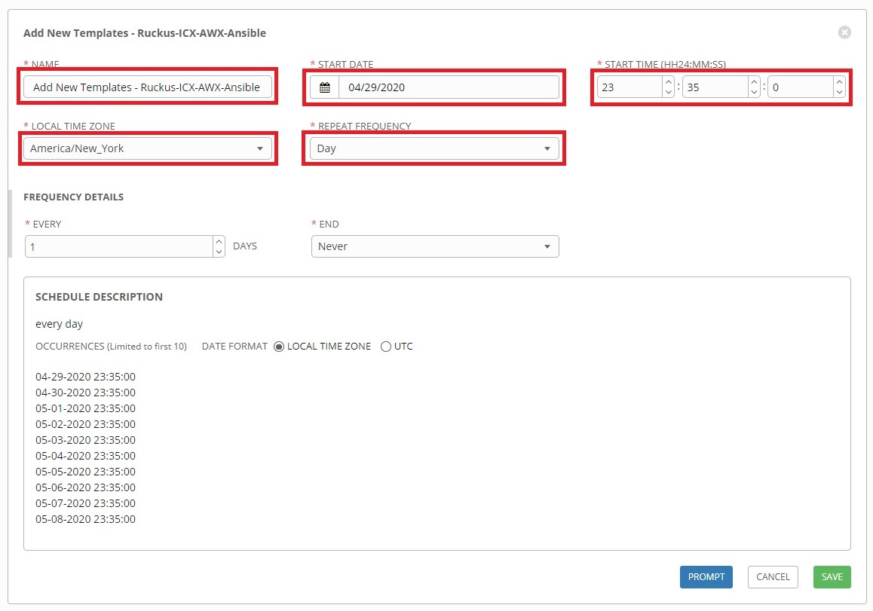

When finished, click the **Prompt** button.

The survey prompt window for the template will open. The first tab of the window will ask for credentials for running the scheduled job if the template was not already setup with credentials. For **Credential Type** select **AWX REST API** then select the credentials created for this type:

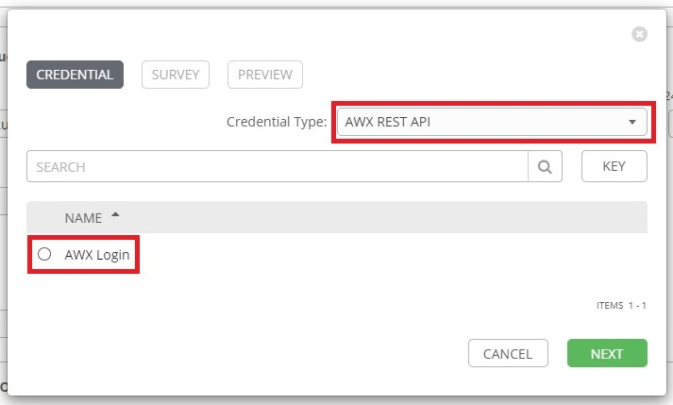

Click **Next**. On the **Survey** tab, select "*Ruckus-ICX-AWX-Ansible*", then click **Next**:

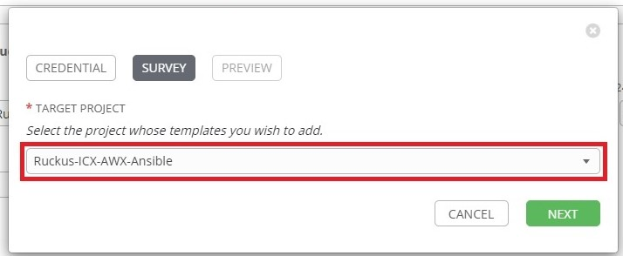

The **Preview** tab will display. Click **Confirm** to complete the prompt and close the window:

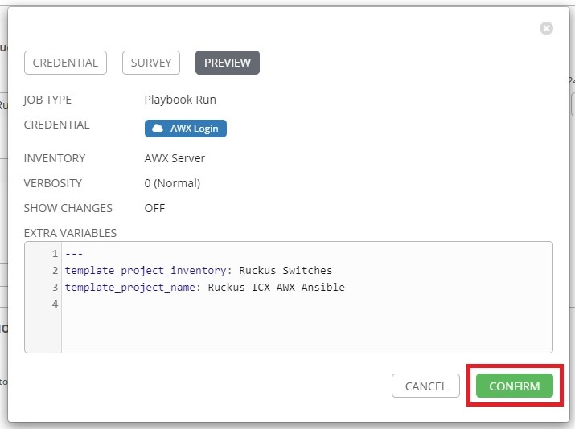

Click **Save**. "*AWX-MGMT-Create-Templates*" is now scheduled to run.

Next "*AWX-MGMT-Update-Templates*" will need to be scheduled as well in order automate the update of preexisting templates.

Click the **Templates** button from the left navigation bar, then click "*AWX-MGMT-Update-Templates*":

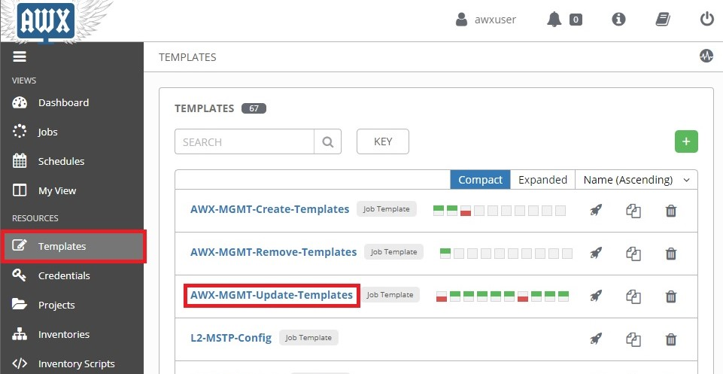

Click the **Schedules** tab, then click the **+** button:

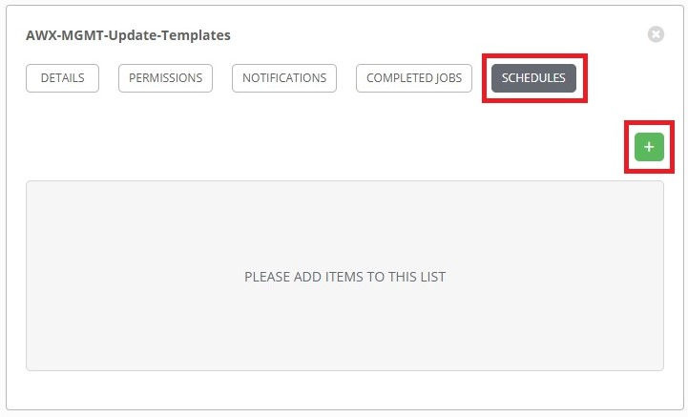

This will open the **Create Schedule** page. Complete the following fields:

**NAME:** Name of the schedule.

**START DATE:** First day the schedule takes effect.

**START TIME:** Time of first run (24-Hour Clock format).

**LOCAL TIME ZONE:** Time zone local to AWX Server.

**REPEAT FREQUENCY:** How often the sync will occur.

The following is an example of a sync that will occur daily at 11:55PM ET starting 4/29/2020:

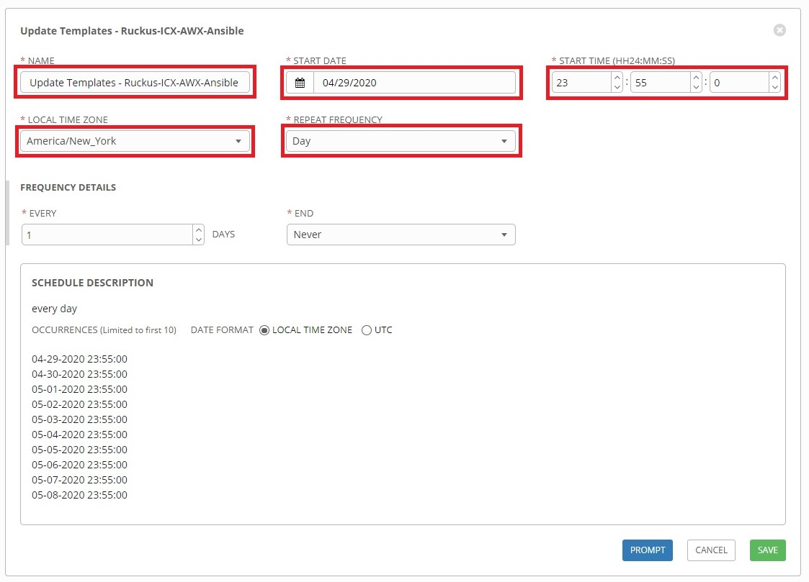

When finished, click the **Prompt** button.

The survey prompt window for the template will open. Select "*Ruckus-ICX-AWX-Ansible*", then click **Next**:

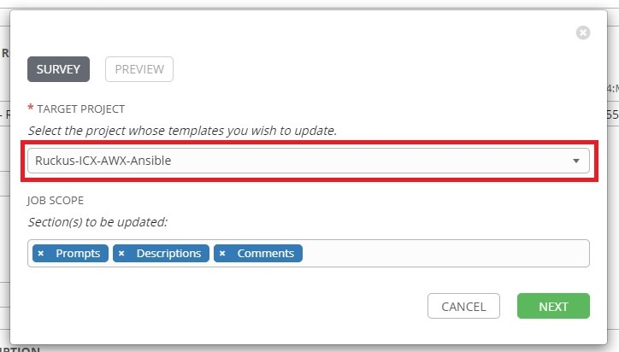

The **Preview** tab will display. Click **Confirm** to complete the prompt and close the window:

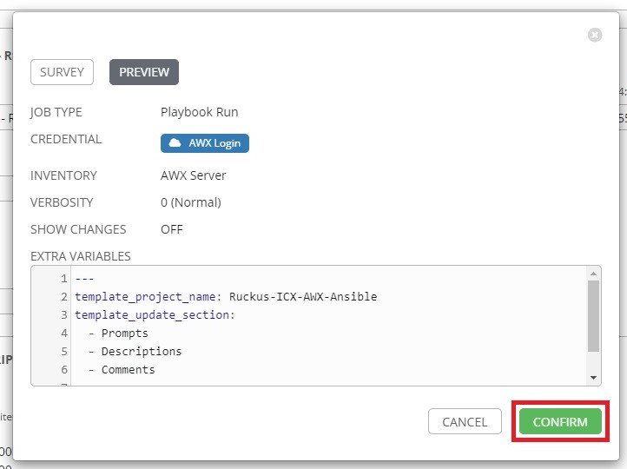

Click **Save**. "*AWX-MGMT-Update-Templates*" is now scheduled to run.